**Supplementary Data 1.** Local fish 12S reference database methodology

The PCR reactions consisted of 0.2 μM of each primer, 0.2 mM dNTP mix, 1X Mg+ free PCR Buffer, 1.5 mM MgCl2, 0.02% BSA, 1 U DNA Taq polymerase (Invitrogen), and 1 ng of DNA template in 25 μL reactions. The thermocycling protocol consisted of initial 5 min denaturation at 95°C, followed by 35 cycles of 95°C denaturation, 61°C annealing, and 72°C extension for 30 sec each; final extension was set for 5 min at 72°C. Amplifications were verified using 1.2% agarose gel electrophoresis, and successful PCR products were sent for paired-end Sanger sequencing at the University of Arizona Genetics Core, Tucson facilities in Arizona, USA.

Sequences were manually curated using Chromas Pro v2.1.10, and complete alignments were conducted using ClustalX v2.1 (Larkin et al., 2007), resulting in 58 unique high-quality sequences. Taxonomic annotations were manually retrieved from the NCBI taxonomy browser (<https://www.ncbi.nlm.nih.gov/Taxonomy/Browser/wwwtax.cgi>; accessed January 15th, 2023), and curated sequences were registered in GenBank (Table S4). We obtained the ~64 bp teleo metabarcode reference for each species using the teleo primers to perform *in silico* PCR with Obitools-ecoPCR (Boyer et al., 2016). *In silico* PCR was unsuccessful for 14 species, for which the metabarcode region was extracted by performing complete alignment against the available references using ClustalX v2.1 (Larkin et al., 2007). To assess species discrimination of the teleo metabarcode within our new species, a complete alignment distance tree was plotted using FigTree v1.4.4 (Rambaut, 2010). To evaluate the availability of genetic references for the 12S teleo barcode, we created Venn diagrams using TaxonTableTools (Macher et al., 2021) to compare Gulf of California fish found in GenBank against our local reference and our method-combined fish species list for cryptobenthic and conspicuous fish.

**Supplementary Data 2.** 12S eDNA sequence processing

We employed a different bioinformatic approach compared to the annotated OTUs using fixed similarity thresholds outlined by Valdivia-Carrillo et al., (2021). We used the ANACAPA pipeline (Curd et al., 2019) to create a custom 12S reference database, obtain amplicon sequence variants (ASVs) from 12S sequences, and perform taxonomic annotation of ASVs within a Bayesian framework. First, we used the CRUX module with default parameters to create a genetic reference library of the 12S teleo metabarcode. We used the European annotated nucleotide (ENA) vertebrates repository (143rd version, downloaded June 7th, 2021; Kanz et al., 2005) as seed for ecoPCR *in silico* amplification (Boyer et al., 2016) and the NCBI annotated nucleotide repository (downloaded February 16th, 2023) for blastn search of all available 12S sequences. Our local fish references and associated taxonomy were manually incorporated into the CRUX reference and converted to Bowtie format.

Sequencing reads underwent quality control and ASV parsing using ANACAPA's second module. Primers and adapters were removed using cutadapt (Martin, 2011), allowing a 30% mismatch. Sequences with an average Phred33 score below 30 and shorter than 40 bp were discarded using FastX-toolkit (Gordon & Hannon, 2010). ASV parsing was performed using DADA2 (Callahan et al., 2016), allowing a minimum sequence length of 40 bp and 20 pb minimum overlap with a maximum of 2 mismatches for forward and reverse read alignment. The ANACAPA classifier module was then used to assign taxonomy to ASVs using a modified version of the BCLA algorithm in Bowtie 2 v2.3.5 (Langmead & Salzberg, 2012) under default parameters and 100 bootstrap replicates to assess the robustness of phylum to species-level annotations (see Table S5for complete ANACAPA parametrization).

The resulting 12S raw ASV table contained read counts per sample, sequence identity, taxonomic annotations from species to phylum, bootstrap scores, and GenBank IDs from the matched references. Firstly, we removed all ASVs found in the negative control pool to avoid false positives due to contamination. We also removed global singletons, which pose a higher risk of including false positives, and poly G-tailed ASVs that matched as likely PCR or sequencing errors (see Table S6 for filtering steps). Taxonomic annotations were manually curated, eliminating uncertain annotations with a bootstrap score below 70 (i.e., any ASV annotation that didn’t align to the same reference in at least 70% of bootstrap replicates).

Subsequently, we manually reviewed all taxonomic annotations to retain fish from the Gulf of California. Taxa were retained if species or genus appeared in any of the following taxonomic lists: (i) our local fish genetic references, (ii) visual surveys, (iii) collections, or (iv) historical records. For genera not found in the previous step, we performed a second verification by consulting the Shorefishes (Robertson & Allen, 2015) and FishBase (Froese & Pauly, 2002) repositories to confirm the genus distribution in the Gulf of California. These filtering criteria excluded conspicuous genera *Etheostoma* (55 ASVs, ~800k reads)*, Genicanthus* (8 ASVs, 484 reads)*, Grammistes* (2 ASVs, 26 reads)*, Naso* (1 ASV, 8 reads)*, Oreochromis* (2 ASVs, 95 reads)*, Paracaesio* (2 ASVs, 7 reads), *Percina* (4 ASVs, 350 reads), *Pholidapus* (10 ASVs, 216 reads), *Ruvettus (1 ASVs, 4 reads), Sargocentron (7 ASVs, 1,966 reads)* and *Siganus* (1 ASV, 2 reads).

Finally, we excluded all reads and ASVs exclusive to three samples with low amplicon richness (fewer than two standard deviations below the mean of kept samples, i.e., lower than 2,340 ASVs). All filtering steps and resulting ASVs and sequence counts are available in Table S6. We kept a clean and curated ASV contingency table for the 25 high-quality samples, containing phylum-to-species annotations for subsequent analyses.

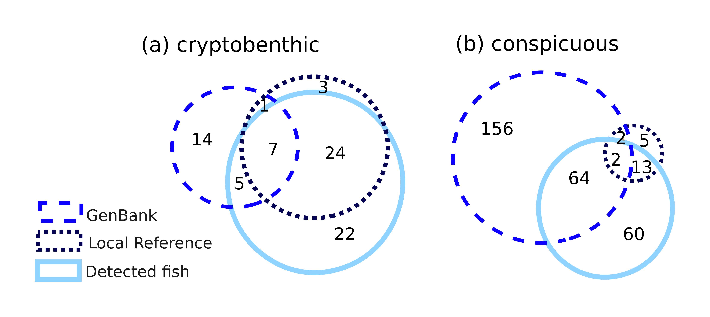

**Figure S1.** Genetic reference availability comparison for cryptobenthic and conspicuous fish species from the Gulf of California. Venn diagrams showing 12S metabarcodes found in GenBank, in our local reference, and all detected species in the field.

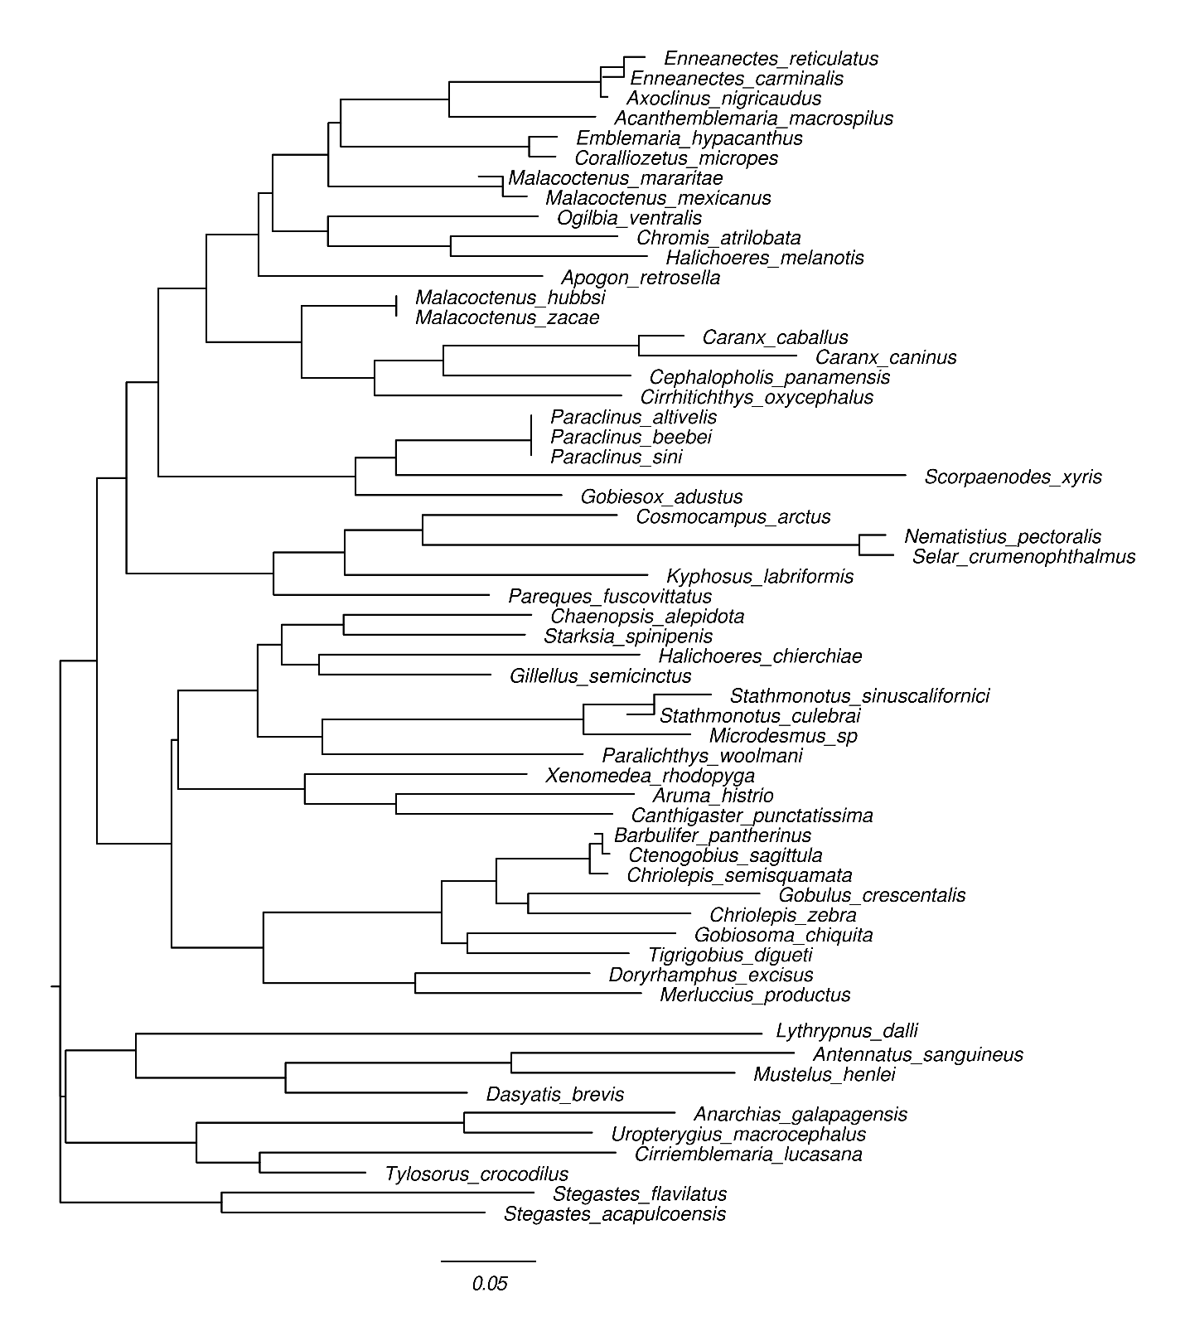

**Figure S2.** Genetic distance tree created from complete alignment of the teleo metabarcode obtained from 59 local fish species.

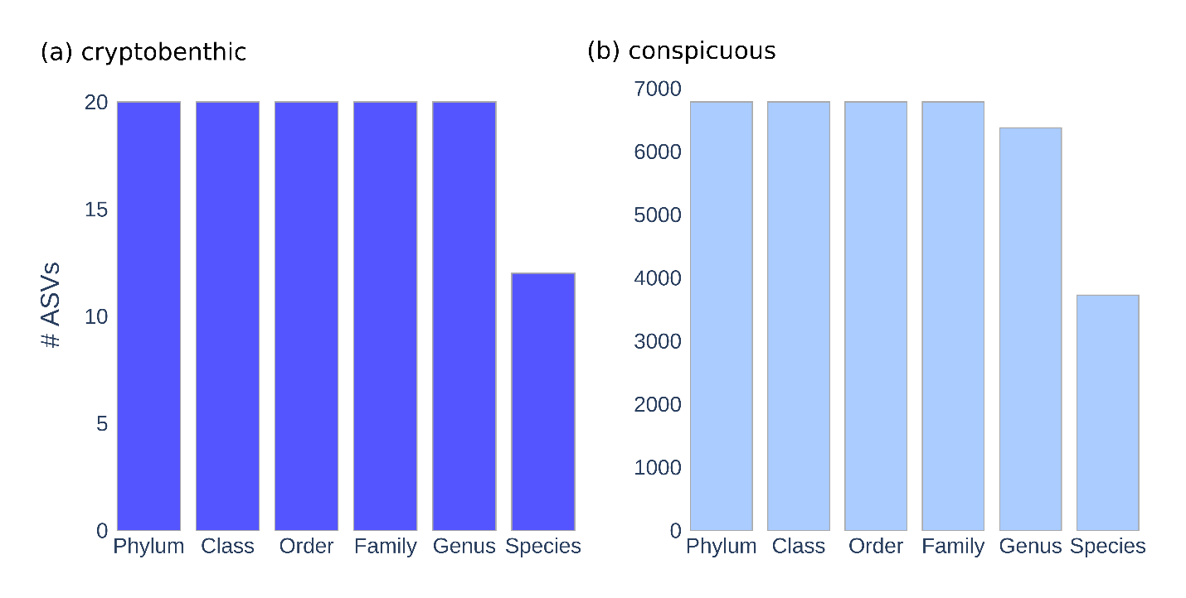

**Figure S3**. Taxonomic rank resolution for 12S eDNA metabarcoding. Number of ASVs identified per taxonomic rank for cryptobenthic and conspicuous fish. Exact ASV counts are shown above each bar.

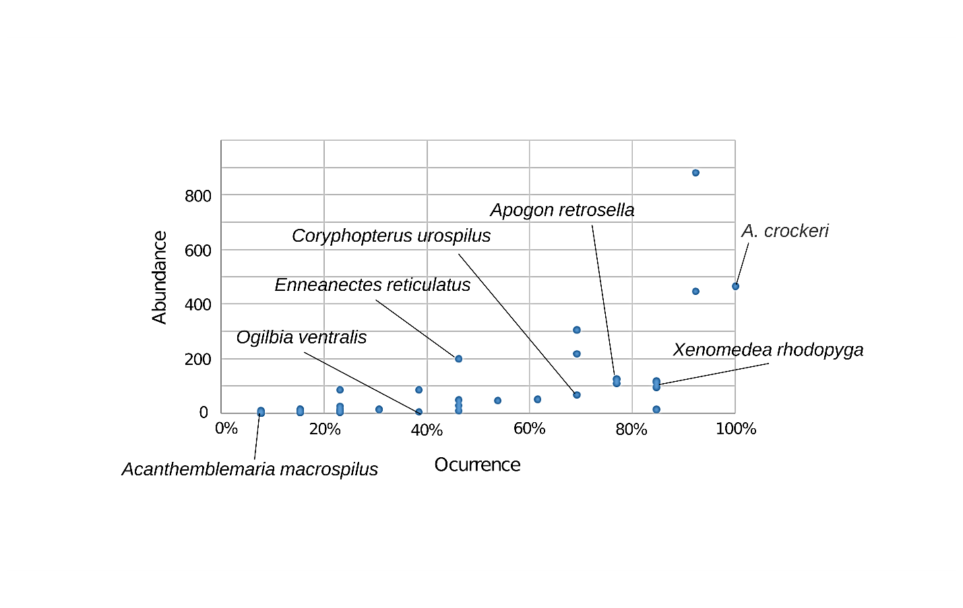

**Figure S4.** Abundance and frequency distribution plot from collected cryptobenthic species. The species noted were collected by 12S eDNA metabarcoding, except *Acanthemblemaria crockeri*, a widespread and abundant sister species of detected *A. macrospilus*.

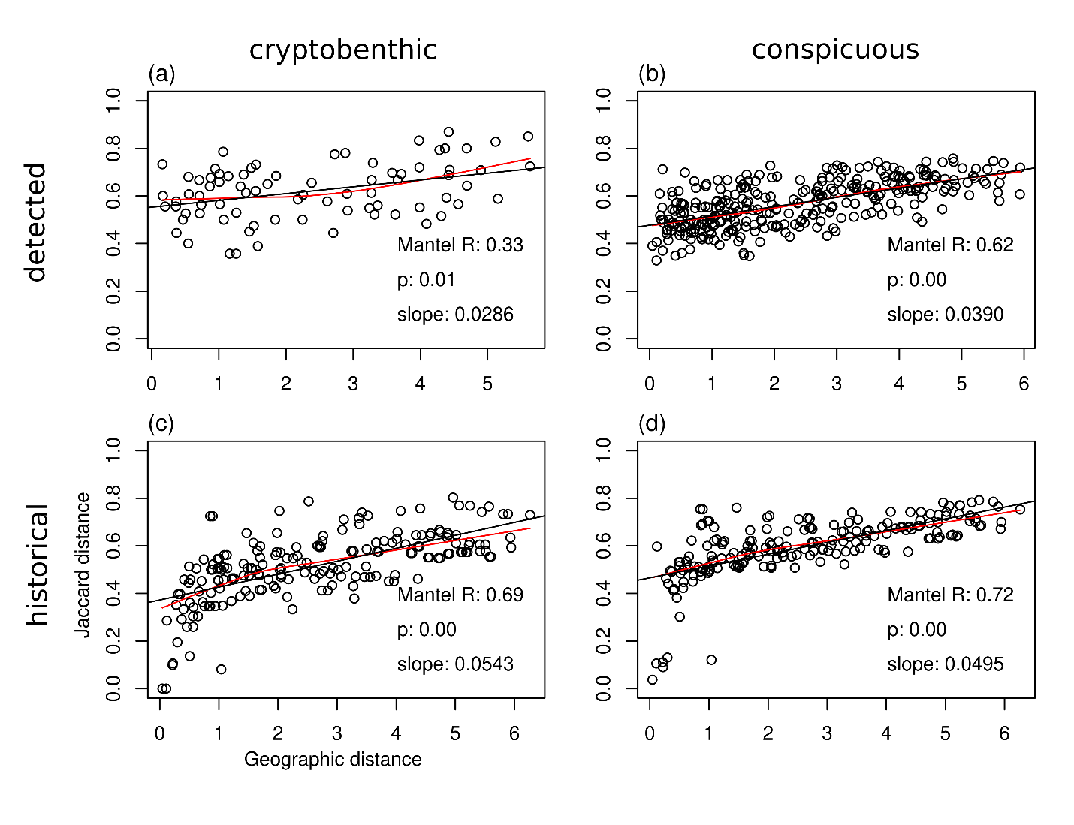

**Figure S5.** Mantel test for distance dependence in community composition for method-combined detected and historical cryptobenthic and conspicuous fish in the Gulf of California. The straight line is a modeled regression among distance matrices, and red smoothed line follows raw data dispersion. Mantel’s R statistic and p value are noted.